Notes on the AACI Website Design

***Purpose of the document:***

This document mainly acts as a basic guideline when developing any new websites for AACI. It is advised to review the document before the implementation, as it provides background knowledge and general structure of the website as well as some basic principles.

Last Update: April 29, 2020

**Development Teams** **2**

**General Design Rules** **2**

**Website Color Choices** **2**

**Website Design Choices** **3**

Fonts 3

Font Size 3

Buttons Design 3

Others General Notes 4

**Frequently Used Design Patterns** **4**

Card Structures 4

Content Structure with Right Sidebar 4

Navigation headers in the Banner 5

# 

# 

# Development Teams

Main AACI websites (<https://www.aaci-cancer.org/>)  
 Designed and implemented by Blue Archers, professional website developer in Pittsburgh. This is the main website of AACI, and displays all crucial information of the organization. Blue Archer is still maintaining the main website as of May 2020.

Public Policy Resource Library (<https://aaci-library.org/>)

Designed and implemented by CMU IS Consulting students in Spring 2019. This website is designed to promote sound public health policy at the state and local level. The students are not responsible for maintaining the website after May, and it is currently maintained by a third party developer Mark Busnelli as of May 2020.

Federal Legislation Tracker (not yet published)

Designed by CMU IS Consulting students in Spring 2020. This website is designed to provide a platform to share important updates of federal legislation status over AACI members. The students are not responsible for developing and maintaining the website. The website is still under refinement and maintained by developer Mark Busnelli aas of May 2020 before the release.

# General Design Rules

As AACI is a serious organization dedicated to cancer research and related fields, the design of the website should be consistent whenever possible. This includes very consistent color choices and font choices, similar design patterns, and similar icon and button designs. It is important to let the readers experience the same design over all pages of AACI websites.

# Website Color Choices

*Note: Display color only. Printing color should refer to AACI or Blue Archers

Color choices should always refer to the main AACI website at (<https://www.aaci-cancer.org/>). Here are some of the selected colors. 

#034380 #78A22F #009FF2 #F9B217 #999999



#00D09C

# 

# Website Design Choices

## Fonts

AACI mainly uses two fonts, Karla and PlayfairDisplay. PlayfairDisplay is for the headings can be either the serif font or the all-caps styled sans serif font used normally on buttons. Karla is for the body text, and always on sans serif font.

## Font Size

Font size is coded often in em. The requirement is not absolute, but it would be more consistent to follow the font size deployed by the main websites.

Common font size includes:

3.75 em, 3 em, 2.25 em, 1.87 em, 1.25 em, 1.12 em, 1 em, 0.87 em

## Buttons Design

The buttons are in all caps sans serif Karla font at pure white #FFFFFF, with a blue #034380 rectangle surrounding the text. When the surrounding color is blue, the rectangle color and the text color is switched, whereas the font size and paddings are normally larger since a button above blue background often exists in home pages.

Normal button design (Retrieved at <https://www.aaci-cancer.org/> top navigation section)



## Others General Notes

Other than the notes specifically mentioned above, any design should try to be consistent with either the main website, or any other websites developed in the Public Policy Resource Library. It is advised to review the whole website thoroughly before starting any new development.

# Frequently Used Design Patterns

## Card Structures

(Example captured in <https://www.aaci-cancer.org/>, as of April 29, 2020)

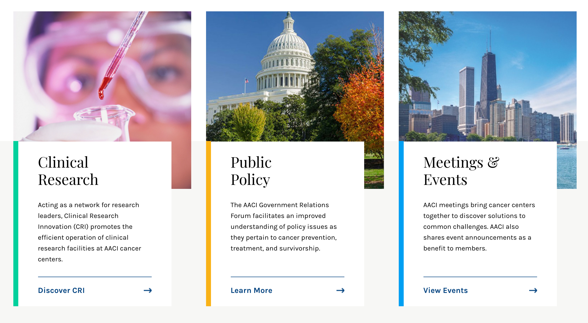

## Content Structure with Right Sidebar

(Example captured in <https://www.aaci-cancer.org/about>, as of April 29, 2020)

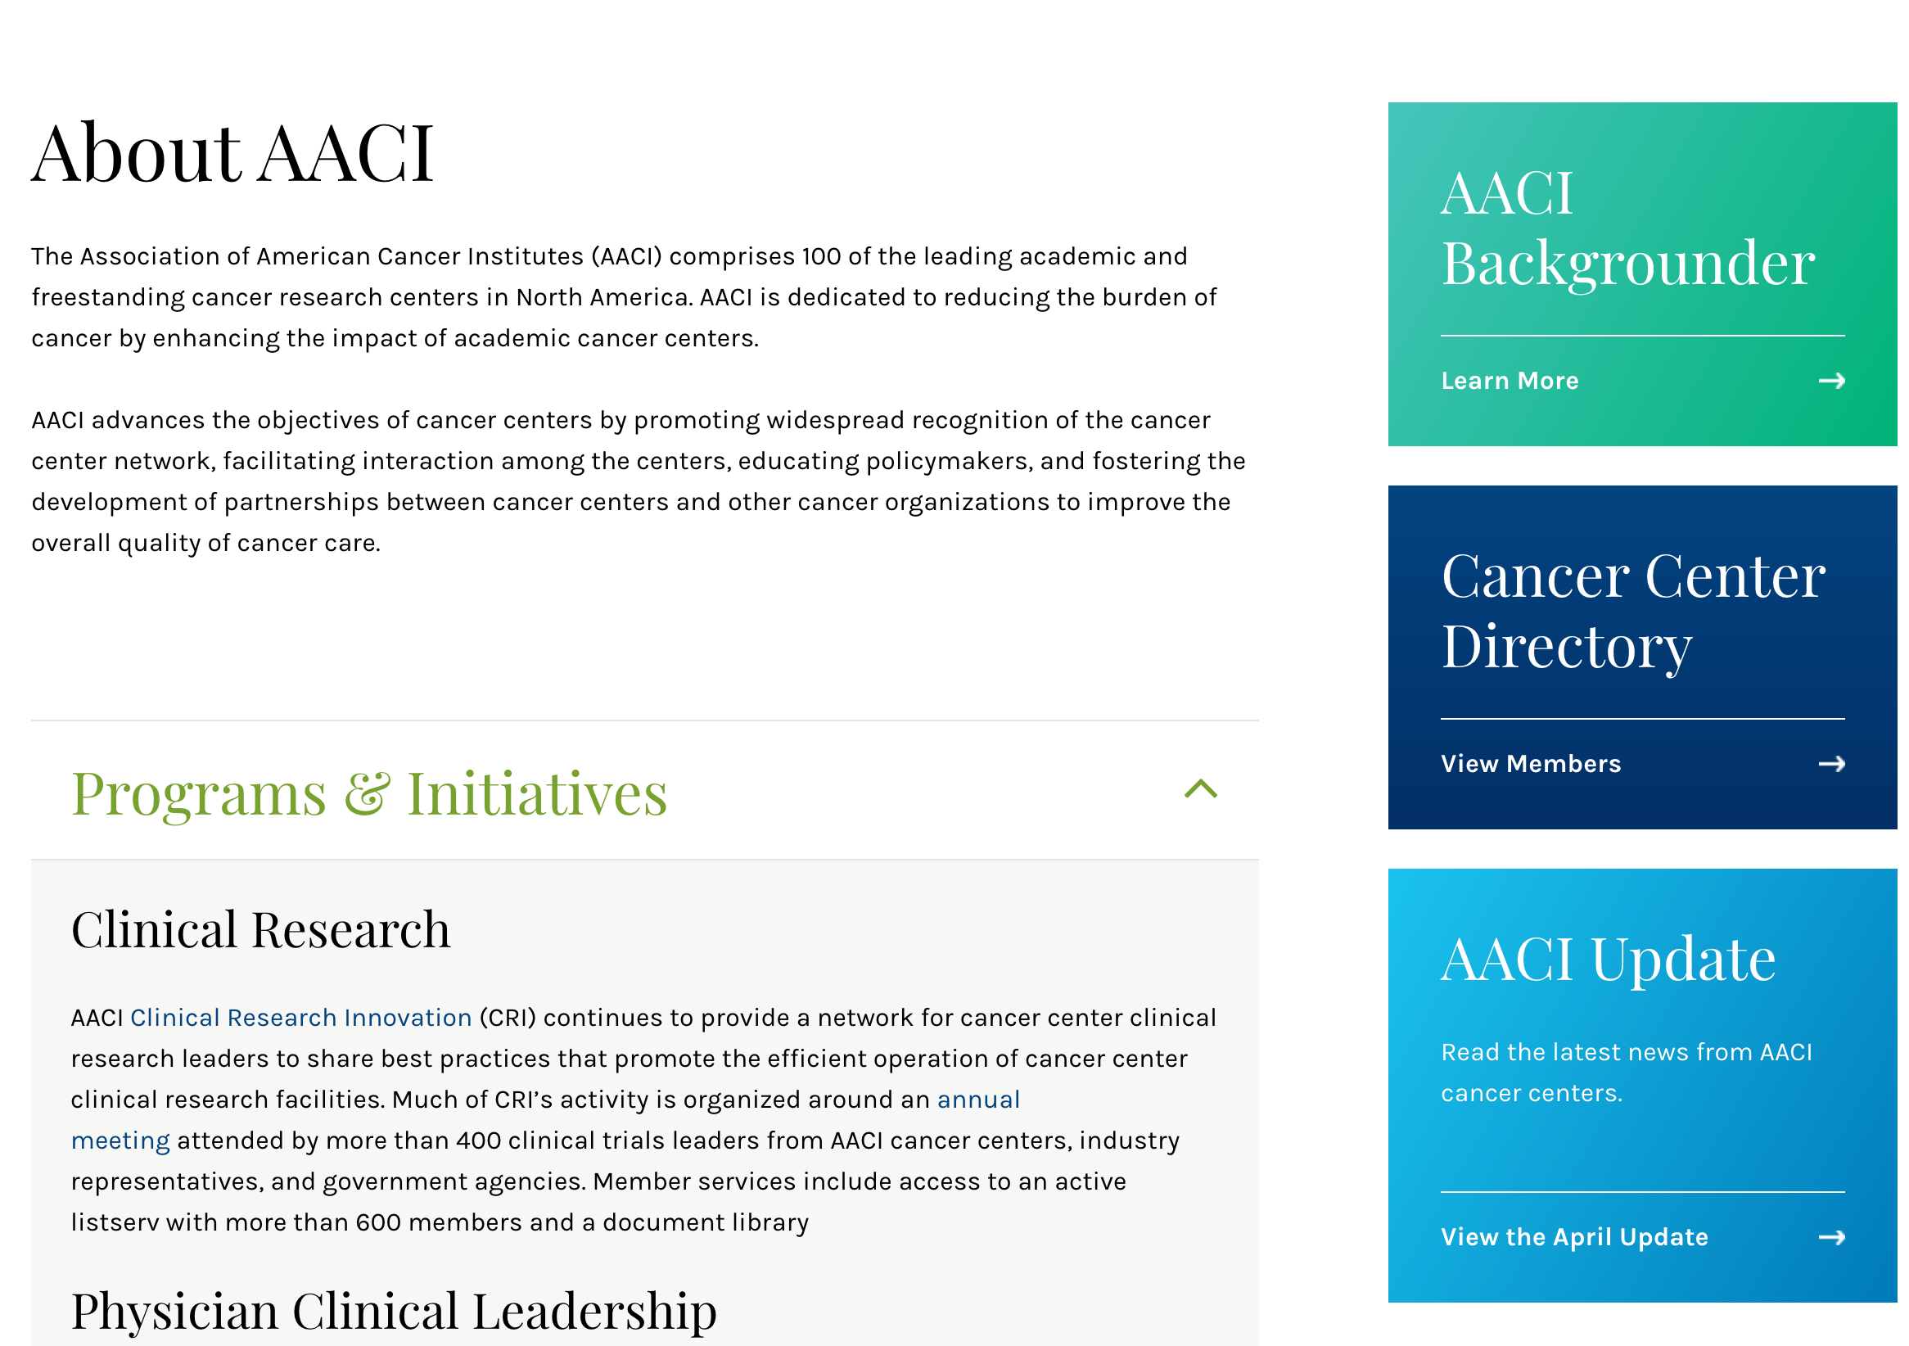

## Navigation headers in the Banner

(Example captured in <https://aaci-library.org/topics/state-funding-for-cancer-research>, as of April 29, 2020)



## 

# 